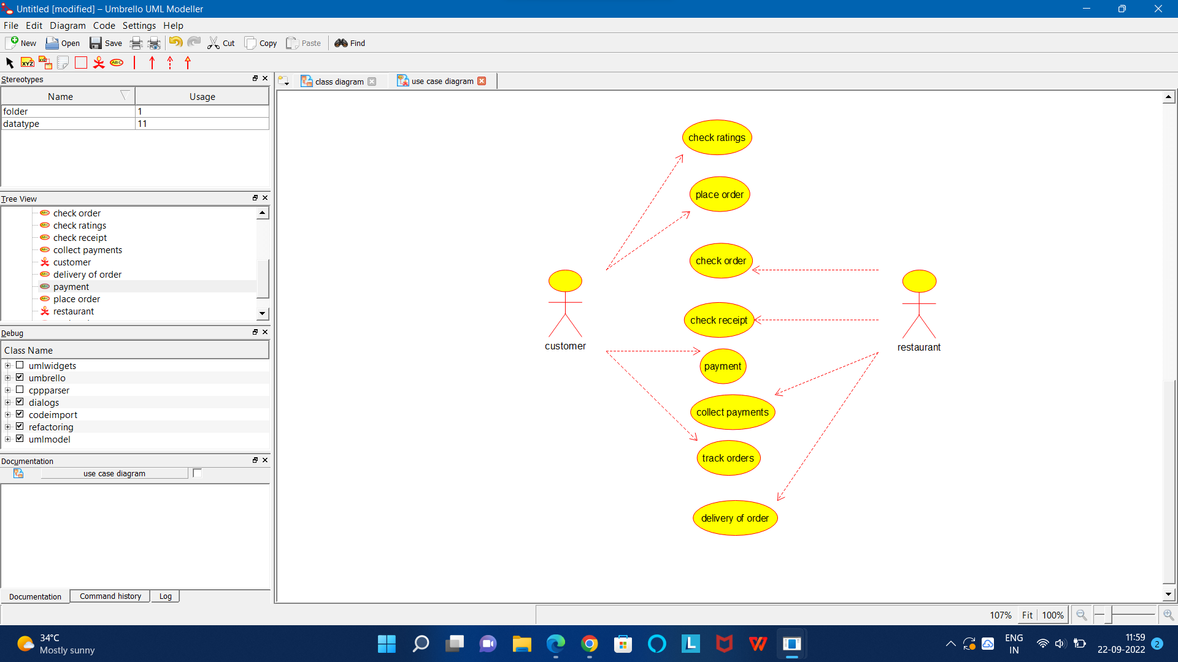

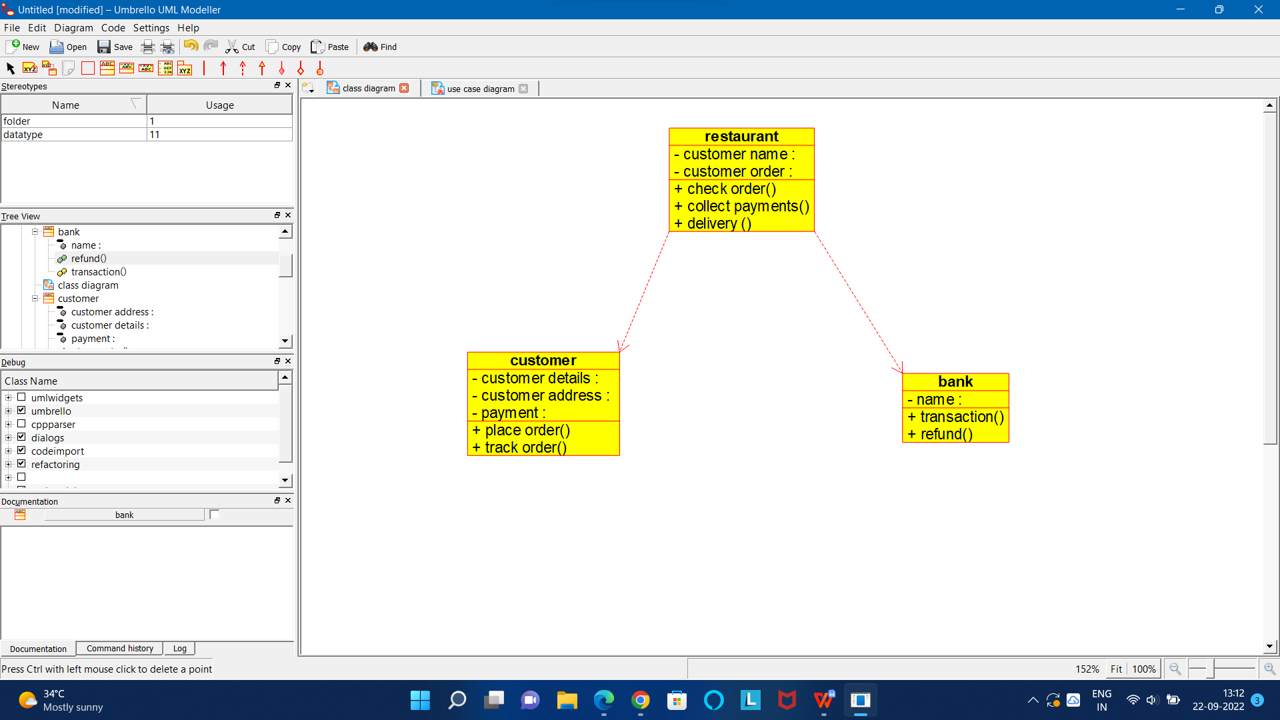

CODE FOR BANK:

/**

* Class bank

*/

public class bank {

//

// Fields

//

private void name;

//

// Constructors

//

public bank () { };

//

// Methods

//

//

// Accessor methods

//

/**

* Set the value of name

* @param newVar the new value of name

*/

private void setName (void newVar) {

name = newVar;

}

/**

* Get the value of name

* @return the value of name

*/

private void getName () {

return name;

}

//

// Other methods

//

/**

*/

public void transaction()

{

}

/**

*/

public void refund()

{

}

}

CODE FOR CUSTOMER:

/**

* Class customer

*/

public class customer {

//

// Fields

//

private void customer_details;

private void customer_address;

private void payment;

//

// Constructors

//

public customer () { };

//

// Methods

//

//

// Accessor methods

//

/**

* Set the value of customer_details

* @param newVar the new value of customer_details

*/

private void setCustomer_details (void newVar) {

customer_details = newVar;

}

/**

* Get the value of customer_details

* @return the value of customer_details

*/

private void getCustomer_details () {

return customer_details;

}

/**

* Set the value of customer_address

* @param newVar the new value of customer_address

*/

private void setCustomer_address (void newVar) {

customer_address = newVar;

}

/**

* Get the value of customer_address

* @return the value of customer_address

*/

private void getCustomer_address () {

return customer_address;

}

/**

* Set the value of payment

* @param newVar the new value of payment

*/

private void setPayment (void newVar) {

payment = newVar;

}

/**

* Get the value of payment

* @return the value of payment

*/

private void getPayment () {

return payment;

}

//

// Other methods

//

/**

*/

public void place_order()

{

}

/**

*/

public void track_order()

{

}

}

CODE FOR FOOD ORDERING SYSTEM:

/**

* Class food_ordering_system

*/

public class food_ordering_system {

//

// Fields

//

//

// Constructors

//

public food_ordering_system () { };

//

// Methods

//

//

// Accessor methods

//

//

// Other methods

//

}

CODE FOR RESTAURANT:

/**

* Class restaurant

*/

public class restaurant {

//

// Fields

//

private void customer_name;

private void customer_order;

//

// Constructors

//

public restaurant () { };

//

// Methods

//

//

// Accessor methods

//

/**

* Set the value of customer_name

* @param newVar the new value of customer_name

*/

private void setCustomer_name (void newVar) {

customer_name = newVar;

}

/**

* Get the value of customer_name

* @return the value of customer_name

*/

private void getCustomer_name () {

return customer_name;

}

/**

* Set the value of customer_order

* @param newVar the new value of customer_order

*/

private void setCustomer_order (void newVar) {

customer_order = newVar;

}

/**

* Get the value of customer_order

* @return the value of customer_order

*/

private void getCustomer_order () {

return customer_order;

}

//

// Other methods

//

/**

*/

public void check_order()

{

}

/**

*/

public void collect_payments()

{

}

/**

*/

public void delivery_()

{

}

}